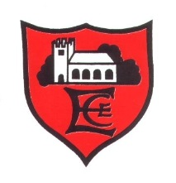

Edenfield C of E Primary School

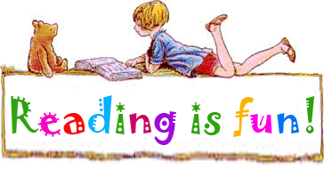

23rd February 2024

Dear Parents and Carers,
We will be launching Reading Week on Monday 4th March to coincide with World Book Day on 7th March. Every class will enjoy a wide range of exciting activities linked to the theme of ‘classic children’s authors’. School will also be hosting a number of events to promote a love of books and reading. These include:
- The Readathon (separate letter attached)
- D.E.A.R. (Drop Everything and Read) initiative throughout the week
- Class teacher swap sessions to share the teachers’ favourite classic children’s books and stories
- Dressing up Day (each class will receive a letter from the teacher) and Parade
- Book Oscars – books will be nominated by pupils and a final vote will result in the Book Oscar Awards
- Lots of exciting reading and writing activities linked to the chosen class author
- Whole school presentation for parents and carers on the stories and novels studied (more details to follow)
- ‘Poster’ competition (see below)
- Read with my ‘book buddy’
- Read with a Grandparent Day
- Drama day with Burnley Youth Theatre linked to class novel for selected classes

Poster Competition

In addition to all of the wonderful activities taking place in school, we would like the children to get involved with our reading theme week by getting creative at home. The task is to create a poster to promote the novel or author chosen for their class. We are hoping to create a beautiful display in the library and there will be prizes for every class for the best posters. Please consider using different materials to create a three dimensional effect and remember to include suitable slogans and eye catching designs to catch the attention of other children to encourage them to read the book or author chosen. In order to raise money for school and to cover the cost of competition prizes, we are requesting an entry fee of £1.00 for each poster – please see entry slip below. Please bring in your poster no later than Friday 3rd March, clearly labelled with your name and class on the back of your design.
For further inspiration, the authors selected for each class are as follows:
- Class R: Eric Carle
- Y1: Julia Donaldson
- Y2: Michael Bond
- Y3: Roald Dahl
- Y4: C.S. Lewis
- Y5: Michael Morpurgo
- Y6: Michelle Magorian

We are looking forward to a successful week of reading challenges. Please keep checking the website gallery for a range of photographs capturing the week’s events.
Yours faithfully,

C L Garner
Headteacher
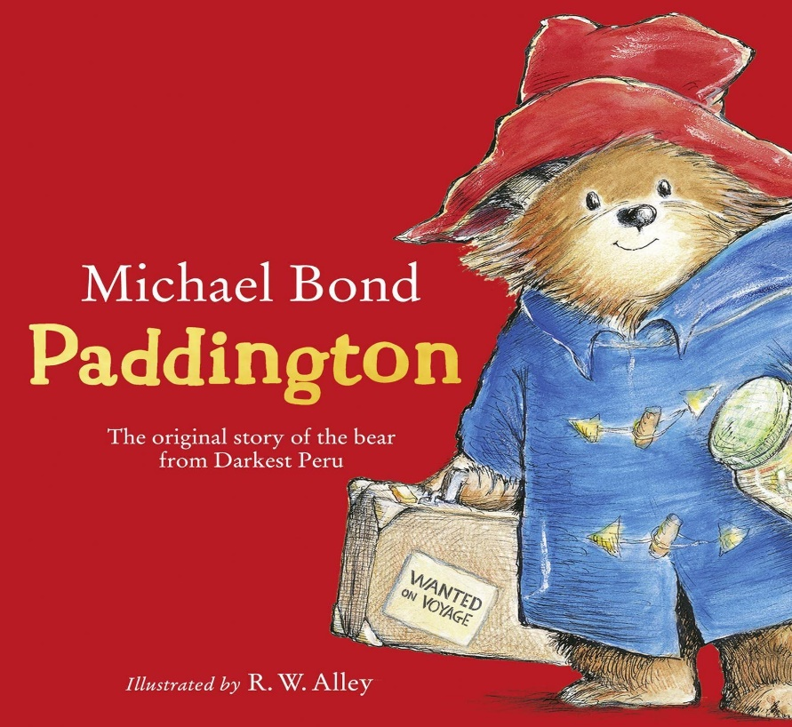

…………………………………………………………………………………………………………………………………………………………

Poster Competition 2024

Poster entry from: ………………………………………………… Class ……………….

I have paid my child’s entry fee via ParentPay

Signed: ……………………………………………………… (parent / carer)

