

Edenfield C of E Primary School





School Prospectus
School Prospectus
An Introduction from the Headteacher/Contact Details……………………………….. 3
Mission Statement…………………………..………………………………………….. 4
General School Information……………….…………………………………………… 5
The Before and After School Club……….…………………………………………….. 5
The School Day…………………………..……………………………………………... 6
Staff ……………………………………..……………………………………………… 6
Governors……………………………….………………………………………………. 8
Admission and transfers………………..……………………………………………….. 9
School Meals…………………………..………………………………………………… 10
Healthy Eating………………………..…………………………………………………. 10
Home School Agreement…………..……………………………………………………. 10
Newsletter………………………..……………………………………………………… 11
Pastoral Care…………………….………………………………………………………. 11
Safeguarding …………………….……………………………………………………… 11
Safety & Access………………….……………………………………………………… 12
Behaviour and Discipline………….…………………………………………………… 13
School’s Council and Pupil Voice……………….………………………………………. 14
School Uniform ……………….………………………………………………………... 15
Parent Teacher Association……………………………………………………………... 16
Emergencies…………………………………………………………………………….. 16
Medicine in School……………………………………………………………………... 17
The Curriculum - from planning to delivery………………………………………….... 17
PSHE - Personal, Social and Health Education ……………………………………….. 21
Reading ………………………………………………………………………………… 21
Homework……………………………………………………………………………… 22
Reporting to Parents/Carers…………………………………………………………….. 22
Information Sessions……………………………………………………………………. 22
Special Educational Needs …………………………………………………………….. 22
More Able Pupils…………….…………………………………………………………. 23
Inclusion………….…………………………………………………………………….. 23
Weekly Teaching Hours…….………………………………………………………….. 24
Attendance ……….……………………………………………………………………. 25
Standards………….…………………………………………………………………… 25
Equality………………………………………………………………………………… 27
Racist Incidents….…………………………………………………………………….. 28
Complaints……….…………………………………………………………………….. 28
Pupil Premium………………………………………………………………………….. 28
(Additional documents - term dates and calendar)

an introduction from the headteacher

On behalf of everyone at Edenfield Church of England Primary School: pupils, teachers,
support staff, parents and governors, I would like to thank you for considering our school for your child’s education.

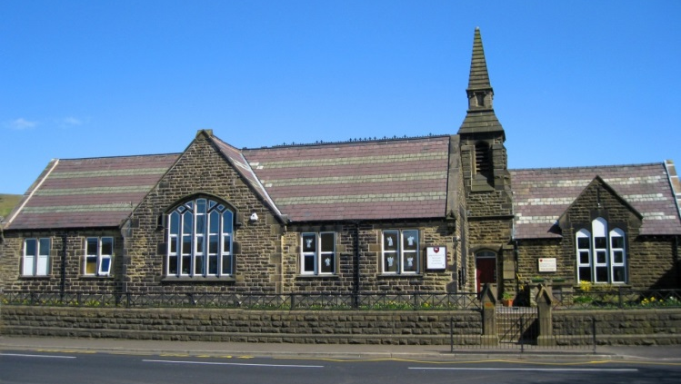
I am delighted to be able to introduce myself to you as the Headteacher of Edenfield C E Primary School and I would like to start by saying how privileged I am to lead a truly lovely school. Our school celebrates: a high level of support and commitment from our hard working staff; excellent relationships with parents and the wider community; a rich, vibrant and exciting curriculum; and most important of all, well-behaved, friendly and enthusiastic children who are eager to learn. All of these elements provide a secure foundation upon which to grow and meet the needs of an ever changing picture within education.

We are extremely fortunate to be housed in a beautiful building within a picturesque rural setting.
A building programme has significantly improved the school, and we now benefit from additional classrooms and enhanced facilities.
Above all, we provide a learning environment where your child is nurtured, cherished and encouraged to fulfil his or her potential.

I hope this prospectus gives you an insight into life at Edenfield School. If you have any questions or concerns, please do not hesitate to phone, or to make an appointment to see me. I look forward to meeting you.

Mrs C L Garner
Headteacher
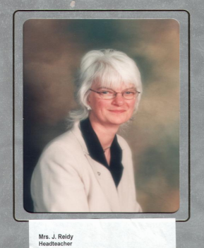
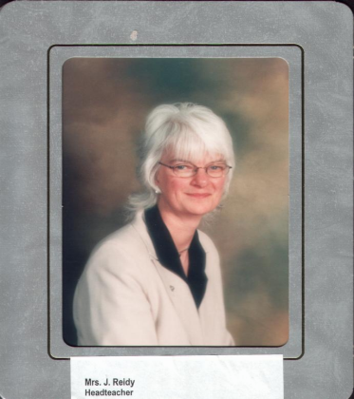
Edenfield C.E. Primary School
Market Street, Edenfield,
Ramsbottom, Bury
BL0 0HL
Tel/Fax 01706 823608
E-mail: bursar@edenfield.lancs.sch.uk
www.edenfieldprimary.co.uk

Our School Vision
All aspects of school life are rooted in our Christian Vision:

Guided by God, following in his footsteps
Our vision is theologically centered on Psalm 119:105
Your word is a lamp for my feet and a light on my path

The word of God is a light on our school pathway; it shows us how to follow the right way. Our pathway will open up horizons of hope and aspiration as we educate our children for wisdom, skills and knowledge and nurture their God given talent and individuality. We foster forgiveness and reconciliation so that all flourish and live well together, embracing difference and treating everyone with respect in our school and church community, and the wider world.

Core Values
Love
Faith
Joy
Hope
Forgiveness
Respect

Our School Code
These are our five promises:
1. Be prepared to do your best and be proud of yourself and our school
2. Be thoughtful and courteous. Respect and listen to the views of others
3. Show consideration for others by what you say and do; be willing to say sorry
4. Always be ready to listen, learn and stay on task
5. Care for our school and everyone and everything in it

GENERAL SCHOOL INFORMATION

Edenfield is a voluntary controlled Church of England Primary School that offers education to children aged 4-11 years. The school serves a village close to the small town of Ramsbottom, north of Bury and was built in 1861 at a cost of £1588.

We are very proud of our refurbished school building. Improvements to the school include a separate EYFS area with outdoor play facilities, three additional key stage 2 classrooms, a dining room and a fully functioning kitchen, from which we can serve our own nutritious hot meals. In addition, we have an improved visitor/reception area, administration and storage space and two offices. We have also recently renovated the Reception outdoor area. The EYFS now boasts a bespoke, outdoor play area which promotes learning and development through play.

We offer two playgrounds and an extensive school field with a
picturesque backdrop of the hills around Edenfield. At the bottom
of the sports area, there is a soft play facility with an adventure
playground made of recyclable plastic where children can climb
and use their imagination for role play.

The recently restored wildlife area provides, seating for outdoor
lessons, a learning circle and flower beds cared for by
each class.

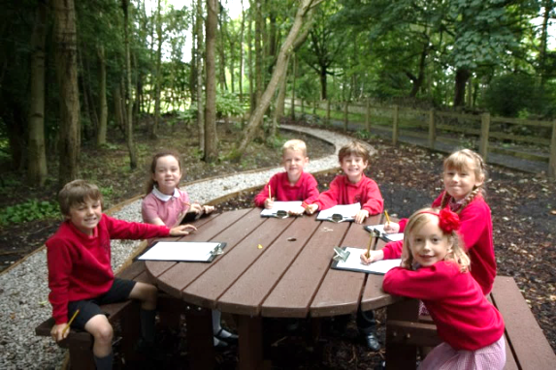

BEFORE AND AFTER SCHOOL CLUB

A very successful Before and After School Club operates in school. They operate from 7.45 a.m. - 8.50 a.m. in the morning and from 3.20 p.m. – 6 p.m. after school. This club is extremely popular and provides wraparound care for parents and carers.

CLASS ORGANISATION

Class | Year Group
Class R | Reception
Class 1 | Year 1
Class 2 | Year 2
Class 3 | Year 3
Class 4 | Year 4
Class 5 | Year 5
Class 6 | Year 6

We offer single age group classes across school, each with approximately twenty seven pupils and two permanent members of staff.
The School Day
FROM SEPTEMBER 2024:

Morning Session 8.50 a.m. to 12.00 noon (infants)
12.15 p.m. (juniors)
Afternoon Session 1.15 p.m. to 3.20 p.m. (juniors)
1 p.m. to 3.20 p.m. (infants)

Playtime 10.30 a.m. to 10.45 a.m. (whole school)
2 p.m. to 2.15 p.m. (infants only)

Children should arrive at 8.40 a.m. when the doors open for immediate access into school. Registration will take place at 8:50 a.m.

STAFF

We have eight teaching staff (including the Headteacher), supported by a range of excellent classroom support staff. The children are divided into seven classes and each class teacher has full responsibility for your child’s learning and social development. The Headteacher and each class teacher are happy to speak and meet with parents at any time, although for practical reasons, an appointment is often advisable.

Your first point of contact at school will often be the School Office Manager, Mrs Nicola Rhodes, who will be able to answer any queries that you may have, and if not, will know the person who can.
The children are supervised at lunchtime by a number of welfare assistants who are also trained to provide the pastoral care to which we believe your child is entitled. Mr. Hakan Agri, our site supervisor, cares for the school buildings.

STAFF LIST

Mrs C Garner (Headteacher)
Mrs C Hartley (Deputy Head)
Teaching Staff
Mrs C Garner
Mrs C Hartley
Mrs S Hope
Miss B Harris
Miss C Greenhalgh
Miss A Scotland
Mr A Cartridge
Mr S Holt
Mrs L Ashworth
Mrs A Parkinson

Office Staff
Mrs N Rhodes (School Office Manager)
Mrs R Hardwick (Administration Officer)

Teaching Assistants/Support Staff
Mrs J Higgins
Mrs M Blake
Mrs L Morris
Miss L Booth
Mrs A Martin
Mrs J Butterworth
Mrs L Berens

Site Supervisor
Mr Hakan Agri

Welfare Staff (Lunch-time)
Mrs R Hardwick
Miss L Booth
Mrs A Martin
Mrs J Butterworth
Mrs L Berens
Mrs M Smith

The staff…. as seen through the eyes of the children.



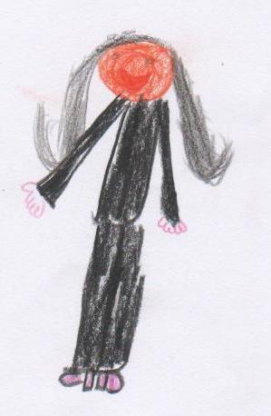










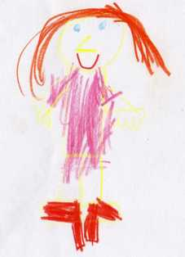
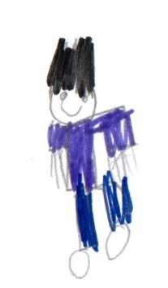
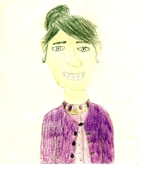

Governors

Mrs Barbara Dewar is the Chair of Governors. A full list of school governors is displayed in the school entrance area, on the school website or available from the office.

The Governors of Edenfield C.E. Primary School play a vital role in providing strategic leadership, ensuring accountability and acting as a critical friend. They support the school, the Headteacher and all stakeholders in promoting high standards of educational achievement and the welfare of pupils. They are involved in monitoring and evaluating school aims and objectives, school targets and policies.

Further information about the full Governing Body can be found on the school website.

ADMISSION OF PUPILS

Edenfield C.E. Primary School offers a primary education to children aged 4 to 11. The admission of a child to this Controlled Primary School is the responsibility of the Education Authority. The maximum number to be admitted each year is currently 30. If at any time there are more applications than there are places, the criteria for selection are those laid down by Lancashire Education Authority.

The information packs for admissions for 2025-2026 are now only available as a digital toolkit. Please click on the links on the school website to access all the information required, or telephone the school for further assistance.

Priority will be given to:
- A child in public care, (Looked After Child) who is in public care at the time the preferences are expressed and are still expected to be in public care when admitted to the school.
- A child who has a brother or sister already attending the school excluding Year 6; this includes stepchildren, half brothers and sisters, adopted and foster children who are living at the same address.
- A child for whom the Authority accepts that there are strong medical, social or welfare reasons for admission.

The remaining places will be allocated with reference to the distances:

• Between home and the school of the parents’ preference.
• Between home and the nearest alternative school at which a place is available.

Priority will normally be given to children who would have the furthest distance to travel to the nearest alternative school at which a place is available. If you are not allocated a place in the school then you have a right of appeal. Please contact the school or the Education Office for more details (see below).

The Pupil Access Team, The Globe Centre, St James Square, Accrington BB5 0RE
Tel: 01254 220711

We are delighted to take children’s names on our ‘expression of interest’ list at any time. In the autumn term, prior to the September in which your child is due to start, every parent and carer on our list will be invited to our Open Day which takes place in October.

We are eager that parents make the correct choice of school for their child and would strongly recommend that parents and carers take advantage of the opportunity to see the school at work and ask questions relating to the school’s philosophy and ethos before making a final decision. Appointments to view the school at work can be made, at any time, by telephoning school on 01706 823608.

Before your child begins school, they are invited to attend a number of half-day sessions to introduce them to the school’s routine, and there will also be a parents’ meeting in June. Full details of our induction process will be provided if your child is offered a place at our school.

In order to facilitate a smooth transition from pre-school provision to Edenfield School, the new Reception children currently attend school for half a day during the first two weeks of term: one week of mornings and one week of afternoons. Full time schooling commences at the start of the third week.

ADMISSIONS TO HIGH SCHOOL

Children from Edenfield may express a preference for any of the local high schools. We have very good links with all the local high schools and liaison with these schools is promoted in a variety of ways. Children attend organised ‘taster’ days; high school staff, visit our school; and children may also attend individually organised high school visits.

In the autumn term of Year 6, parents and carers are required to make their secondary school applications. Places are then allocated in the spring term by the local authority. Full details of how this system operates are contained on an information poster which Year 6 parents and carers receive.

LUNCH-TIME
At lunchtime, children can stay for a nutritious school dinner, freshly prepared on a daily basis in our kitchen. Menus are provided on a termly basis. The cost of a school lunch is currently £2.70 per day for junior children and can be paid weekly or half-termly in advance via ParentPay (see below). Infant children currently receive free school dinners as part of a government initiative.
For information on free school meal eligibility, parents/carers should contact the Education Office on at the Globe Centre, Accrington on 01254 220711.

Edenfield C E Primary operates a cashless system, ParentPay, for all payments, including dinner money, snack shop, voluntary contributions, and educational enrichment activities. The school office will assist all new parents in setting up a ParentPay account which is straightforward and very user friendly.

Alternatively, children may bring a packed lunch from home.

HEALTHY EATING
The school operates a healthy eating policy for playtime snacks. If parents and carers wish their children to have a snack at playtime, they should not send sweets, chocolates, biscuits or crisps. This policy helps to encourage the children to eat healthily, reduce tooth decay and keep the playgrounds litter free.
A Government initiative is in place for the infant children: each child is given a free piece of fruit every morning. Juniors are encouraged to bring a piece of fruit from home. The contents of packed lunches are left to parents’ and carers’ discretion, although we do discourage cake and chocolate bars. Fizzy drinks and sweets are not allowed.
SNACK SHOP
We have a morning break snack-shop which is run by our in house Lancashire Catering Team and proves extremely popular with the children. Payments for morning toast and snacks are payable half termly in advance, via ParentPay.

HOME SCHOOL AGREEMENT
Schools are now required by the D.F.E. to have home-school agreements in place. This document is given to all new parents and carers to sign when their children start school. It outlines what is expected from the school, the parents and carers, and the children themselves.

NEWSLETTER
All parents and carers receive a fortnightly newsletter which is available online, and distributed to children on alternate Fridays. It aims to inform everyone about events that have taken place in school during the week, or events that are due to take place, as well as celebrate the achievements of the children and school.

PASTORAL CARE
The headteacher and class teachers are responsible for the well-being of the children in their care. Parents and carers who are concerned about their child, for whatever reason, should contact school without delay. We are here to help and most problems are readily solved as a result of a chat and the bringing of the problems, or anxieties, to the class teacher’s attention. If we are concerned about your child’s work or behaviour, we will contact you. The school is able to offer a fully qualified ELSA (Emotional Literacy Support Worker) and identified pupils benefit from weekly nurture sessions. Education is very much a partnership between school and home and we value parental support and involvement in the learning process.

SAFEGUARDING
Everyone who comes into contact with children and their families has a role to pay in safeguarding children. School staff are particularly important as they are in a position to identify concerns early and provide help for children to prevent these concerns from escalating. At Edenfield Primary School, the staff form part of the wider safeguarding system for children. Mrs Garner is the designated safeguarding lead, she provides support to staff members to carry out their safeguarding duties and liaises with other services such as social services, police and health to promote the welfare of children and protect them from harm.
THE ROLE OF SCHOOL STAFF
- All school staff have a responsibility to provide a safe environment in which children can learn.
- All school staff have a responsibility to identify children who may be in need of extra help or who are suffering, or are likely to suffer, significant harm. All staff then have a responsibility to take action, working with other services as needed.
- Action will also be taken to promote the welfare of a child in need of additional support, even if they are not suffering harm or at immediate risk.
- School staff may be expected to support other agencies to take decisions about individual children.

All school staff (teaching and non-teaching) receive appropriate and regular child protection training.

Typical safeguarding practices include:
- Regular and up to date safeguarding training (including PREVENT training)
- Thorough induction for all visitors and volunteers including a thorough rigorous vetting system
- Safer recruitment – strict procedures are adhered to during the appointment of all staff and volunteers
- Keeping the premises secure, safe and fit for purpose
- Risk assessment procedures for school activities both in school and during educational visits
- Online safety training and teaching
- A broad, balanced curriculum which teaches children how to keep themselves safe and provides positive life affirming experiences for all
- Annual update of the Child Protection and Safeguarding Policy

Staff and volunteers are able to raise concerns about poor or unsafe practice in the school’s safeguarding regime. Appropriate whistleblowing procedures are in place for such concerns to be raised with the school’s management team.

The full Safeguarding Policy can be accessed via the school website.

INFORMATION SHARING
We have an obligation to obtain necessary information from parents in advance of a child being admitted to school, including:
- Emergency contact numbers
- The child's special dietary requirements, preferences or any diagnosed food allergies
- The child's special health requirements
- Information about who has legal contact with the child and who has parental responsibility for the child
Written parental permission is requested, at the time of the child's admission. We take confidentiality very seriously; any information which we hold is treated as confidential and in line with the recent Data Protection Guidelines 2018. Please see our Data Protection Policy and Privacy Policies (on the school website) for further details.
LINKS WITH EXTERNAL AGENCIES
We are fortunate to be supported by a range of external agencies which can be called upon to support the work we do in school. These include School Nurse, Health Practitioners, Educational Psychology, Behaviour Support, Social Services and Specialists in supporting Special Educational Needs.
REVIEW OF POLICY AND PRACTICE
In order to ensure that best practice is maintained, our policies are reviewed at least yearly, and when new statutory guidance emerges.

SAFETY AND ACCESS
- Parents and carers must not enter school via any of the external classroom doors. All visitors into school must sign in at the main office, where they will be given a visitor badge.
- The school crossing warden is on duty at the front of school for half an hour before school and 20 minutes after school.
- To enable the children to cross in safety, please do not park immediately outside school. It would also be helpful if parents and carers do not park in Church Court.
- Parents and carers are asked to arrive at school punctually at 3.20p.m. to collect children at the end of the school day.
- Due to safeguarding procedures, all school gates will remain locked until 8.40a.m. They will be locked again at 8:50a.m. prompt to signal the start of the school day. At the end of the school day, the infant and East Street gate will re-open just before 3.20 p.m. and be locked at 3.30 p.m. If your child is attending an extra-curricular activity after school, designated exit gates will re-open at 4.15p.m. and be locked at 4.20p.m. The Before and After School Club has its own separate security and access arrangements.

BEHAVIOUR

School staff, pupils and parents should be clear of the high standards of behaviour expected at all times. Good behaviour is encouraged through a mixture of high expectations and an ethos which fosters discipline, and mutual respect between pupils, and between staff and pupils. We use a range of options and rewards to reinforce and praise good behaviour, and clear sanctions for those who do not comply with the school’s behaviour policy.

We aim to promote excellent behaviour through positive reinforcement and reward. We encourage the children to make good choices and acknowledge and reward these choices. Every pupil belongs to a house: Cedar, Elm, Rowan or Willow. House points are collected by each child; they work as a team to try to win the house trophy each half term and they also earn rewards on an individual basis. Every half term, the children aim to be the house point champion for their house. The children also accumulate house points on an ongoing basis and every child can achieve recognition for their efforts.

In each class, we use the Star, Sun and Cloud system to promote positive behaviour management. Each day the children’s names are placed on the sun. The aim is to remain on the sun and reach for the star.

Pupils who are placed on the star will receive a ‘Star of the Day’ reward card and a special mention in the weekly awards assembly. If a pupil breaks one of the five promises, their name is moved on to the cloud. Throughout the day, they have the opportunity to correct and improve their behaviour and be moved back on to the sun. If at the end of the day, a pupil’s name remains on the cloud they will receive a cloud card and the sanction of one missed playtime. Typical behaviours which will result in being placed on the cloud include:
- Consistent low level disruption (e.g. shouting out, making noises, moving out of class place without permission, distracting others)
- Name calling
- Unkind or thoughtless acts towards others
- Disrespectful behaviour to pupils or staff

By following the school code, children are entitled to thirty minutes of Golden Time every Friday. We offer a wide range of enrichment activities and the children choose a new activity each half term. We also use a bead jar in every class to encourage team participation. Beads are awarded for exceptional conduct and when the jar is full, the class is rewarded with a theme day or a ‘whole class treat’ selected by the children and their teachers.
Other rewards include:
- Star of the Week certificate
- Headteacher Award Cards
- Teacher Award Cards
- Star of the Day cards
- Subject Postcard Awards
The full Behaviour Policy can be accessed via the school website.

SCHOOL COUNCIL

We also have a School’s Council which is made up of representatives from each year group. These children are voted for by their own class or year group, and they stand for a year. They meet with a member of staff each month to discuss ways to improve the school. We aim to implement many of their suggestions such as, purchasing a friendship bench and new playtime game resources.

SCHOOL ETHOS COMMITTEE

KS2 pupils may also sign up to join the Ethos Committee. This group works collaboratively to promote the school’s Christian vision and core values through a variety of projects and charitable initiatives. They also regularly plan and deliver whole school worship.

SCHOOL SPORTS LEADERS

These are a group of Y6 pupils who work together to promote the six School Games Values of: passion, self-belief, respect, honesty, determination and teamwork. They also plan and host school intra-school and inter-school sporting competitions, as well as feeding back sporting achievements to the wider school community.

SCHOOL MENTAL HEALTH CHAMPIONS
Year 5 Young Mental Health Champions are a group of pupils with an interest in their own health who want to help others in making healthy lifestyle choices that affect mental health. They act as ambassadors and mentors, providing important health information and advice to their peers, as well as helping to affect real and lasting change in our school. These young people continue to develop their knowledge and understanding of key physical, social and mental health issues affecting them today through interaction and engagement with athlete mentors.

SCHOOL UNIFORM

 | Boys | Girls
TOPS | Plain red polo shirt  Plain red sweatshirt (with school logo if possible) | Plain red polo shirt  Plain red sweatshirt or cardigan (with school logo if possible)
BOTTOMS | Grey tailored trousers or shorts | Grey skirt (no more than 2 inches above the knee) or tailored grey trousers
Grey pinafore
or red checked dress in summer
FOOTWEAR & SOCKS | Black shoes  NOT trainer style  Grey or black socks | Black shoes no more than 1 inch heel  NOT trainer style  NO fashion boots  Plain socks or tights (white, grey or black)
P.E.KIT | Red crew necked t-shirt (with school logo if possible)  Black shorts, pumps  Black jogging bottoms and warm red top for cold days.  Trainers or football boots  Plastic bag for dirty kit  Pump bag
JEWELLERY | Only wrist watches are allowed  Earrings are strictly forbidden, any children wearing earrings will be asked to remove them.  Leather friendship style bracelets are not allowed
Please note that embroidered uniform items are available from Amin’s Clothing on Bank Street, Rawtenstall and My Clothing Service (http://www.myclothing.com)
Important Bag Update
Due to increasing numbers of pupils and limited cloakroom space across the school, rucksacks and large bags are not allowed across all classes. Please use a book bag for school equipment and a named drawstring kit bag for PE. This will still apply in September 2024. The dimension of the book bag should be approximately W37cm x H31cm x D6cm. Please note, large bags will be sent home. Please use a drawstring kit bag for PE.

Shoe Reminder
Children must NOT wear fashion boots or trainer style shoes for school. These are not permitted. Please ensure your child wears a proper school shoe from September through to July. Trainers are not acceptable even in July. You will be asked to replace inappropriate footwear.

Hairstyle Reminder
The number of unsuitable hairstyles has increased recently and from September 2024, failure to comply with school uniform policy will result in further action. Certain hairstyles, extreme cuts, and colours are not considered appropriate for school, are not compatible with uniform policy, bring unwanted attention to children and disrupt learning. Please also ensure hair decorations and headbands reflect school colours and are not overly large.

Personal equipment and pencil cases are not allowed in school. We will continue to supply children with an individual pencil case.

Mobile telephones are NOT be allowed in school under any circumstances, this is in line with our online safety policy.

We expect all children to present themselves smartly, and require the staff to do likewise.
‘Please put your child’s name on everything!

PARENT TEACHER ASSOCIATION

Our purpose built EYFS Play Area

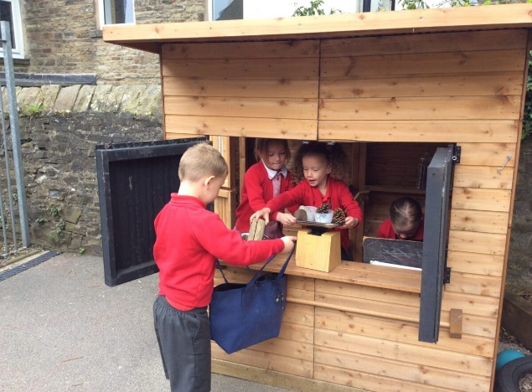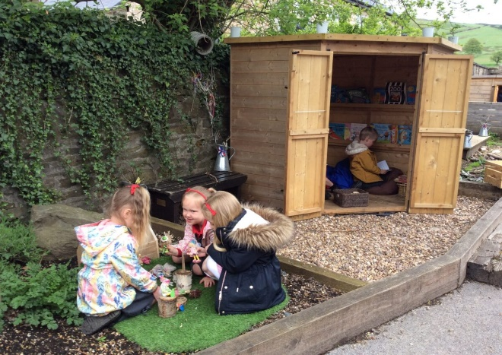

The school has a PTA, which supports the work of the school in many ways. There are social, as well as fundraising events. New parents and carers are automatically members of the PTA and are always made welcome at meetings, as are ex-parents and carers, and friends of the school. The meetings usually take place on a half-termly basis in the school.

The PTA has provided vital equipment and resources for school, and we are most grateful for the additional funds they raise for the benefit of the children. Without their contributions and hard work we would not have been able to raise the money that was needed for the Early Years Play Area, climbing equipment, ICT resources (including our new state of the art interactive android TVs), and a wide range of educational visits.

Several events are held during the year, including the Christmas Fair, the Summer Fair and Fun Run, and the Rossendale Triathlon. These have raised many thousands of pounds for school and really do make a difference to the education of the children. We look forward to new parents and carers helping us in the future.

EMERGENCIES
It is essential that we have up-to-date information regarding medical conditions, addresses, telephone numbers, emergency contacts and family doctors. In the unfortunate event of an emergency, school will always attempt immediate contact with the family or family representative. If contact proves impossible, school will act in ‘loco parentis’ and take the necessary steps to ensure that the most appropriate treatment is given.
Please ensure that any changes to the above information are immediately reported to school. All staff are aware of the need to maintain privacy and confidentiality. We take confidentiality very seriously and all information is treated as confidential and shared in school on a ‘need-to-know’ basis only.

ILLNESS AND MEDICINE IN SCHOOL
Please be aware that, in line with government guidelines, we do not administer or store medicines in school. Children, or parents and carers should not bring any sort of medication into school. The only exceptions to these guidelines are inhalers. Should your child require regular or emergency medication in school, we will discuss a Healthcare Plan alongside the School Nurse in accordance with the GP’s advice. Further information regarding illness and medicines in school are available from the office.

THE CURRICULUM - FROM PLANNING TO DELIVERY
In the EYFS, Development Matters is used within the EYFS Statutory Framework to create a scaffold on which to develop a bespoke EYFS curriculum using a progressive curriculum approach. Pupil provision is related to attainment, not age; we strive to ensure every pupil achieves their full potential.
During their Reception year, children work through this bespoke school curriculum towards achieving their ‘Early Learning Goals’. This curriculum is shared with parents on an ongoing basis and strong lines of communication are in place in the EYFS department. Assessments will take place at the beginning, throughout, and at the end of the EYFS.

THE NATIONAL CURRICULUM

In 2014, the Department for Education introduced a new National Curriculum. In line with this statutory requirement, we deliver a bespoke and balanced curriculum to meet the needs of our children and ensure effective progression across the primary phase. We deliver key learning within each National Curriculum subject area and offer: a vibrant mix of first hand experiences and practical activities; opportunities to foster pupil independence and choice; depth and breadth of study; and a wide range of visits and visitors to enhance learning, engagement and enjoyment. Using the school’s bespoke planning tools, we employ a wide range of pedagogies and strategies designed to help pupils learn more and remember more. Building and sequencing knowledge is key to our successful curriculum delivery.

This year, education visits have included:

Delamere Forest, Tatton Park, Eureka, Jodrell Bank, Manchester Airport Visitor Centre, Young Voices UK, Blackpool Tower, Manchester Science Museum, Brockholes Nature Reserve, Staircase House, Stratford Shakespeare Centre, Jorvik Viking Centre, York and Manchester Opera House.



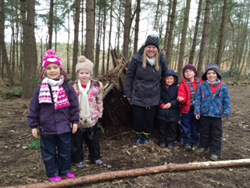
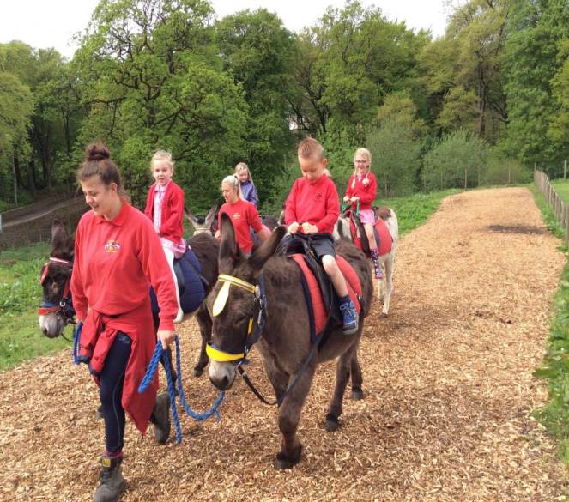

Curriculum Statement of Intent

The overarching intent for the school curriculum at Edenfield C E Primary School is rooted in the school vision:
Guided by God, following in his footsteps
Your word is a lamp for my feet and a light on my path
Our vision is theologically centred on Psalm 119:105

Our curriculum pathway will open up horizons of hope and aspiration as we educate our children for wisdom, skills and knowledge, and nurture their God given talent and individuality. We ensure that each child will fulfil his or her potential and achieve all their goals and aspirations. This will be achieved through our unique and unwavering Christian Ethos which underpins all that we do as the word of God is a light on our school pathway; it shows us how to follow the right way. Effective teaching and learning takes place in our school environment where we foster forgiveness and reconciliation so that all flourish and live well together, embracing difference and treating everyone with respect in our school and church community, and the wider world. As a result, children thrive and flourish whilst being prepared to become responsible citizens.
Edenfield C E Primary school is committed to developing a community of learners where learning is valued, enjoyed, supportive and lifelong. The school will enable children to become confident, resourceful, enquiring and independent learners whilst developing their self-respect and encouraging every individual to respect the ideas, attitudes, values and feelings of others regardless of race and culture. There is a continued emphasis on fostering children’s moral, spiritual, social and cultural understanding through the school’s core values of love, faith, joy, hope, forgiveness and respect.
Innovations in teaching and learning are the foundations for a successful curriculum. The content meets the needs of the statutory requirements of the National Curriculum (2014) and is designed with Edenfield pupils at its heart so it builds on their interests and meet their needs. When children enjoy learning and become active learners, this knowledge and understanding is more likely to be retained, therefore ‘stick’. As a result, children can continuously build on prior knowledge and make exceptional progress. Subject leaders play a vital role in planning the school curriculum so that learning is sequenced, pupils build on prior knowledge, acquire key vocabulary, and progress in the subject within a year group and across all key stages. Leaders know the intent of the curriculum for the subject, plan its implementation and measure and evidence the impact. They monitor teaching and learning, and progress and attainment, so that standards remain high, and where necessary teachers are supported in improving practice within dedicated timescales.
The learning culture at the school encourages children to take risks and recognise mistakes and errors as a learning opportunity and as such the school promotes a 'can do' attitude. Whilst the school demonstrates high expectations in behaviour for learning, and progress in learning and presentation, children are treated fairly with kindness, respect, encouragement, praise and rewards for all. Children are encouraged take pride in their work and the work of others.

The school curriculum recognises that children learn and progress in different ways. It intends to raise aspirations, provide a sense of purpose and relevance, and identify strengths, interests and talents which are celebrated. Learning opportunities incorporate a range of strategies in order to engage children in learning and meet the individual needs of all learners. These will include but are not limited to: investigation and problem solving; research; selecting and using relevant high quality resources to support learning; use of IT including; visual images, film, interactive teaching resources; a termly programme of fieldwork and visits to places of educational interest; high quality, carefully sourced visitors and performances; enrichment activities, including a planned timetable of theme weeks and a wide programme of extra-curricular activities; participation in athletic or physical activity; and setting challenges for themselves. Children will be taught to take responsibility for their own learning.
This personalised school curriculum ensures that the needs of all children are met. High quality teaching, enhanced by a commitment to ongoing professional development, is enhanced by targeted intervention programmes as required. The impact of Targeted Action Plans and interventions are measured and adapted accordingly to promote progress and attainment.
Wellbeing and mental and physical health are prioritised within the school curriculum and the Five Steps of Mental Wellbeing are embedded throughout the school, and referred to during lessons, daily worship and whole school gatherings. The school promotes the firm belief system that mental wellbeing is a normal part of daily life, in the same way as physical health. The curriculum ensures the benefits of physical exercise, time outdoors, community participation, voluntary and service-based activity impact positively on mental wellbeing and happiness. It also includes sharing simple self-care techniques, including the importance of rest, time spent with friends and family, and the benefits of hobbies and interests.
Each teacher builds regular exercise into daily and weekly routines, this includes comprehensive PE coverage in line with the statutory requirements of the national curriculum, a daily active mile and / or other forms of regular, vigorous exercise. Sport and physical activity also helps to develop crucial skills such as teamwork, resilience, determination, confidence and leadership. The vast range of sporting activities on offer meets the needs of a wide range of sporting interests. Every child has the right to be active and to find a sporting activity that they enjoy.

Edenfield C E Primary school, where children come first, is dedicated to ensuring ALL pupils will fulfil their God given potential, celebrate talent and individuality and achieve all their goals and aspirations.

From Year 1 onwards, the following subjects are taught: English, maths, science, ICT, design technology, computing, music, art, PE, geography, history, PSHE and French (Key Stage 2 only). Please see the school website for detailed information on planning and delivery for all of the school curriculum subjects.

Children are assessed by teachers throughout their school lives. Teachers maintain a working knowledge of a child’s attainment and progress through rigorous marking of work, effective and timely feedback, and everyday classroom observations. We keep thorough ongoing records of progress, and set targets for improvement for individual children. These targets are shared with parents.

There are times during a child’s education when more formal assessments will take place, for example towards the end of the school year. Some of these assessments are externally marked. Data collected and analysed from formal assessments in school is reported to the Department for Education as part of their responsibility to monitor standards. Parents are always welcome to seek information about their child’s progress from the class teachers.

RELIGIOUS EDUCATION

All schools are required to include Religious Education in the curriculum. We follow the Religious Education Syllabus for Church Schools, provided by the Blackburn Diocesan Board of Education, as recommended by the Manchester Diocese to which we belong. As a faith school, Religious Education permeates every aspect of the curriculum. Through our RE syllabus, our pupils are helped to grow in experience, knowledge and understanding of the Anglican Church. In addition, we explore other World Faiths and teach the children the importance of tolerance and respect.

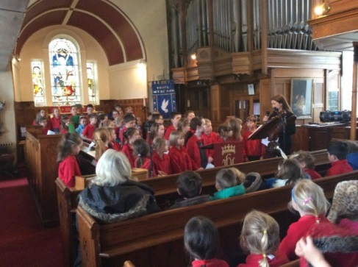
COLLECTIVE WORSHIP
Whole School Worship is held every day, in which Christian moral and social values are developed. School Worship is planned and delivered in line with the requirements of the Manchester Diocese to which Edenfield C.E. Primary School belongs. The children gather together for Christian Worship on a daily basis either as a whole school or as a key stage. Family Worship takes place on a Friday afternoon, and is followed by our Stars of the Week Assembly. Each class takes it in turns to lead Family Worship, where they also share examples of class work. We have a visitor book at the back of the hall and welcome comments in response to our Family Worship Services.
The school curriculum at Edenfield is designed to meet the full requirements of the National Curriculum and the Foundation Stage curriculum, and is in line with the policy statement of Lancashire County Council and vision statement of the school. The school’s curriculum provides opportunities for learning in both the lessons taught as part of the school day, and the extra-curricular activities which deliberately extend and enhance this ‘formal’ curriculum.

PSHE – PERSONAL, SOCIAL AND HEALTH EDUCATION
Our PSHE and RSE policy and scheme of work have now been updated and all classes ensure it is an integral part of our teaching programme considering issues such as working together, keeping to rules and respecting each other. All classes are taught aspects of these subjects within the different “themes” studied. The new 2019 statutory Health Education, Relationships and Sex Education Curriculum (RSE) has now been implemented in line with government requirements. Central to this curriculum is: developing pupils’ ability to believe that they can achieve goals, both academic and personal; to stick to tasks that will help them achieve those goals, even when the reward may be distant or uncertain; and to recover from knocks and challenging periods in their lives. This is complemented by development of personal attributes including kindness, integrity, generosity, and honesty.

READING
We have a strong commitment to ensuring an enthusiasm for reading is nurtured. All pupils are exposed constantly to a rich varied diet of book experiences to ensure comprehension skills are taught and developed, and speaking and listening skills are extended.

In Key Stage 1, we teach systematic, synthetic phonics on a daily basis within a rigorous and well planned framework, Red Rose Phonics (published by Lancashire Learning Excellence), to which we adhere with fidelity. As well as driving phonetic progression, we teach the children ‘context’ or ‘high frequency words’ so they can access rich meaningful stories. We aim for all children to complete the transition from ‘learning to read’ to ‘reading to learn’ by the end of Key Stage 1. Initially, children are taught to read using 100% phonetically decodable graded books (based on sounds taught only) but we also provide children with the opportunity to choose ‘real’ books, to share at home, on a weekly basis.

In Key Stage 2, the emphasis shifts from decoding print and literal comprehension to reading extended prose, poetry and non-fiction fluently, with understanding. Pupils are also encouraged to read for pleasure. We do everything we possibly can to promote wider reading. We also provide library facilities and set ambitious expectations for reading at home. Pupils participate in rigorous guided reading sessions, on a daily basis, where they are taught, for example, to:

- Understand a wide variety of fiction texts
- Retrieve and record information from non-fiction texts (including prototypical and
non-prototypical text types)
- Evaluate the impact of the author’s use of language
- Evaluate and analyse the author’s intentions

How can you help at home?

We recommend the following:
- Listen to your child read out loud at least three times a week. (This should be in a relaxed and quiet environment)
- Read to your children as often as possible, preferably every day
- Use the Home School Reading Record to record reading progress and communicate with your child’s teacher

HOMEWORK
Homework is set by staff on a regular basis. In the Early Years, children will bring home a school reading book and some “key words” to learn with you. As they get older, they will be given spelling lists to learn, and eventually, as they progress through school, they will start to receive regular homework tasks.

Homework is designed to help children to develop and extend their skills across the curriculum, and help them to practise organising their time and commitments in preparation for the transfer to high school. Parental support is obviously vital in this respect and we are often asked how parents can help. It is probably best to try to ensure that your child has somewhere quiet to do their homework, away from distractions and to encourage your child to get into a routine so that work is completed in good time without any rushing or last-minute panic. Discussing homework and encouraging and praising all efforts are very important and help your child to feel confident and happy about their work.

REPORTING TO PARENTS AND CARERS
Parents’ and Carers’ Evenings are held twice per year in the autumn and spring terms to discuss children’s progress and identify key targets for each child for the term ahead. Progress reports are sent home at the end of the autumn and spring term and a comprehensive annual school report will be sent to each child’s parent or carer towards the end of the summer term. This report will comment on academic progress across all subjects, individual achievements, personal development, and general attitude to school life. End of Key Stage 1 and 2 assessments will be reported to parents and carers along with teacher assessments. Further targets for improvement are also included in the school report.
Parents and carers are welcome into the school to discuss their child’s welfare or curriculum issues at any time. However, it will help the organisation of the school if appointments are made in advance.

INFORMATION SESSIONS
Curriculum awareness evenings for parents are held each year in the form of ‘Parent Workshops’. Attendance of these is strongly recommended as further advice and strategies on how to support your child at home are provided. In recent years, areas covered have included: spelling, phonics, reading, mathematical calculations, and mental strategies in mathematics. Every October, we deliver a workshop on phonics and reading for new parents, followed by an additional workshop in February on a specific topic. For example, we recently delivered a workshop on ‘Mental Mathematics across the School’. Information and handouts linked to these workshops can be found on the school website.

SPECIAL EDUCATIONAL NEEDS
In accordance with the school’s commitment to provide equality of education for all pupils, it is recognised that some pupils experience particular difficulty in achieving their full academic potential and other children may have physical, emotional or behavioural needs. Edenfield Primary School is committed to integrating children with special educational needs into the school and will aim to meet the needs of all children with special requirements in line with the national ‘Code of Practice’. The school staff will therefore work together with parents and carers to:

• Implement the school’s “Special Educational Needs” policy
• Develop a positive attitude to school life which increases pupils’ self-esteem and confidence
• Ensure that programmes of study and materials used to deliver them are suited to the pupil’s needs, enabling them to achieve and make progress
• Set appropriate SMART targets within a Targeted Action Plan (TAP) and then assess and report progress in relation to those targets

Where children have more significant special educational needs, the school may involve external agencies and services for further advice, assessment and support. This may lead to the provision of a funded Education and Healthcare Plan, a legal document aimed to support pupils throughout the duration of their education to ensure all of their needs are fully met.

We believe that all children should be given the opportunity to succeed. Where we identify a barrier to learning, we endeavour to overcome this by meeting the needs of the child and helping them to move forwards. This may be possible within the schools own resources, and we may also involve external agencies and services for further assessment, advice and support. Parents are actively involved in this process, as are the children themselves.

Our Special Educational Needs policy is available from school and details of the SEN Local Offer and SEN Information Report are listed on the school website.

MORE ABLE PUPILS
As well as catering for those struggling academically, we make appropriate provision for the most able pupils in school. We provide for able, gifted and talented children in a number of ways. Work in class is differentiated appropriately and offers suitable challenge in all subjects. This year, these children are also working with an additional teacher during study support groups, to help them achieve higher targets of attainment. Talented children, for example, those who excel in Art, Music and Sport are encouraged to join other clubs or organisations which have the expertise to promote these skills. Children who have musical ability are encouraged to play and sing in assemblies, church services or school productions. We also recruit experts to visit school to extend the learning of identified pupils. For example, More Music recently led a music project for pupils identified as more able in this subject.

INCLUSION
The Governors and staff of Edenfield Primary School are committed to providing a high quality education for all pupils. Inclusion is an evolving process, which seeks to celebrate diversity through the identification of, and the minimising of, all barriers to learning and participation.
We recognise the needs of pupils and will provide experiences, which take account of age, ability, gender, ethnicity and social background through appropriate resources and teaching approaches.

We will ensure that the school curriculum and assemblies, in all their aspects, promote multi-cultural education and positive attitudes to world citizenship and takes account of ethnic, cultural and linguistic factors in assessment and review procedures.
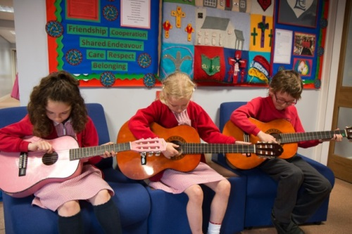
MUSIC AND PERFORMANCE
We aim for every child in Year 3 to be taught a musical instrument through the Wider Opportunities Scheme run by Lancashire Music Service. At present, the children are learning to play the guitar, and in previous years, they have learnt violin and brass instruments.
We are able to offer free tuition for one academic year. As part of the follow on service offered by Lancashire Music Service, children are able to continue lessons after this free tuition has ended. Each year, the children are encouraged to showcase their talents at various public events.
The Lancashire Music Service also provides additional music tuition. Currently, pupils receive tuition in piano, keyboard and guitar. These lessons are organised via a private arrangement between the Music Service and parents. Tuition is held during school hours on school premises. Please contact the school office for further information.
Every year, Key Stage 1 children take part in the nativity performance, which gives them the opportunity to develop their singing, dancing and drama skills. Key Stage 2 children stage a Summer Production at the local high school, where they perform in a drama theatre, using all the sound and light technology, to provide a professional performance for all to enjoy.

We have a flourishing school choir who recently won the regional heats of Lancashire’s premier singing competition ‘Last Choir Singing’. We have performed in the grand final for three consecutive years and in 2018, we were awarded the county runner up award.

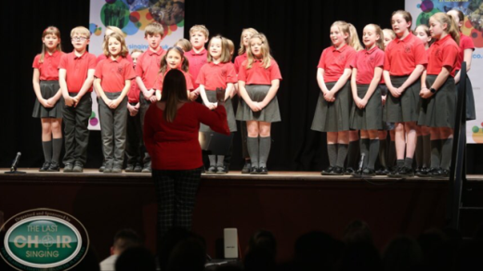

Extra Curricular Activities
The following clubs are currently offered at different times during the year:
Football Dancing Tennis Computing Public Speaking Running
Art Netball Recorder Skiing Cricket Gardening Cheerleading
Singing Judo Athletics Infant Sports Gymnastics Graphic Design Horse Riding Construction and Lego Friends at Play

The school participates in local leagues for various sports.

Additional study support sessions also take place with selected children, outside of the normal school day.

WEEKLY TEACHING HOURS
In accordance with D.F.E. guidelines, the school operates the following weekly teaching times:
Infants (Key Stage 1): 32.5 hours
Juniors (Key Stage 2): 32.5 hours

These hours include, lunchtimes and playtimes.
In addition, there are multiple after school enrichment activities after school, on offer every day.

ATTENDANCE
If your child is unable to attend school, please notify the school office by 9.30 a.m. on the first day of absence.
At Edenfield School, we have a termly ‘Traffic Light’ system as a way to ‘grade’ attendance at school. At the end of each term, we send out attendance certificates and reports to inform you of your child’s attendance level and to highlight areas of concern.

The minimum attendance level which is expected for all primary aged children nationally is 95% and our target is 96%. Good attendance is very important so that children are given as much opportunity as possible to develop academically and socially. When children are absent from school they often find it difficult to catch up on the work they have missed.

At the end of each term a summary of your child’s attendance will be included with the school report. This includes a colour coded chart:
- GOLD - this means that your child has achieved 100% attendance, which is above Government expectations and will help us as a school reach our target. Well done!
- SILVER - this means that your child has only missed 1 day or less. Well done!

- GREEN - this means that your child has attendance which is on or above the minimum level recommended by the Government, 95%.

- YELLOW - this means that, whilst your child's attendance is not yet 'concerning', they have attendance of below 95% but above 85% and have therefore had an above average amount of time off school. It may be that these absences have been due to illness or a holiday, but we feel you should be aware that your child's attendance is below the minimum level recommended and so does need to improve.

- RED - this means that your child has had significant periods of time off school (below 85%) and is at risk of underachieving as a result. We would ask for your support in ensuring that, where possible, attendance improves. Your child's attendance will be monitored on a regular basis and we may invite you into school to discuss this further.
If, following a red report, your child’s attendance does not improve we will contact you again in order to discuss the situation further and may require you to attend a meeting in school. It may also be necessary to ask the Local Authority Attendance Officer for assistance in this matter. We ask for the support of parents in improving attendance levels, as we believe that this is one of the main ways in which our children will be happy at school and achieve their full potential.

STANDARDS
Our school received a monitoring visit from Ofsted in November 2023. As this was an ungraded inspection, there was no possibility of a change in grade at this time; however, the report indicates that had it been a graded inspection, the evidence gathered suggested the school would now be outstanding.
As a result, the inspector has actioned another inspection which should take place within the next one to two years; this will be a graded inspection which will give us the opportunity to move from Good to Outstanding. This places us directly back in the Ofsted window but we are determined to continue to deliver the very best in care and education for our children and families, and hopefully this will be recognised in due course.
Highlights of the report include:

- Pupils are happy to attend this thriving school, which is at the heart of the local community. They form positive relationships with staff. Staff expect pupils, especially those who are disadvantaged, to do their very best. Pupils achieve exceptionally well.
- School leaders and the governing body share a strong vision for the high-quality education that they want to provide for pupils. This has allowed the school to develop a positive culture of high expectations.
- Teachers have the subject knowledge and expertise required to deliver the full breadth of the curriculum confidently. They design learning that is enjoyable and helps pupils to develop their understanding of concepts. Teachers make explicit connections to pupils’ prior learning. This helps pupils to develop a rich and cohesive body of knowledge.
- The school has suitable processes in place to identify the additional needs of pupils with SEND. It ensures that these pupils receive any extra help that they require to access the curriculum successfully… As a result, these pupils achieve very well.
- Teachers have extremely high expectations of pupils’ behaviour in classrooms and across the school… pupils are adept in managing their own behaviour.
- Classrooms are warm, welcoming learning environments where pupils feel comfortable and confident to express themselves.
- The school has carefully considered the programme that supports pupils’ wider development. It has placed a strong emphasis on teaching pupils about the wide range of cultures and religions that make up modern British society. Pupils who spoke to the inspector confidently articulated their learning about a wide range of topics. This includes how to stay safe online and strategies to maintain their mental and physical health.

Our aim has always been to provide a broad and balanced curriculum which caters for all our children. Our motto is “where children come first” and we believe that every child has the potential to succeed. In line with our school Christian vision statement, it is our philosophy to discover the strengths and talents of every child and ensure they reach their true potential.

We are also proud of our school’s excellent attendance and behaviour. We aim to ensure our children adopt healthy lifestyles, promote good relationships and safe practices. We aspire for our children thoroughly enjoy their education and feel they are cared for, guided and supported.

As we are a Church School, we were also inspected by the Diocese in 2016. The most recent report concluded we were outstanding in all areas. The inspector noted, “The distinct Christian ethos of the school in action provides outstanding care, nurture and guidance for all the pupils.”

In 2017, our outstanding results in mathematics in KS2 placed us in the top 1% of primary schools in the country. Nick Gibb, Minister of Education, wrote to the school and praised the high standard of teaching and learning in place. The letter states: ‘I would like to congratulate you and your staff on your school’s very high standard of achievement in mathematics in the 2017 Key Stage 2 assessment. Thank you for your hard work and professionalism in producing such high standards.’

Equality

Edenfield C E Primary School is an inclusive school, working towards greater equality in the whole school community. The curriculum and teaching is used to enhance the self-esteem of all those it serves and to provide a learning environment in which each individual is encouraged to fulfil her or his potential. For our school this means understanding, and tackling, the different barriers which could lead to unequal outcomes for different groups of pupils in school, whilst celebrating and valuing the achievements and strengths of all members of the school community

Equality at our school permeates all aspects of school life and is the responsibility of every member of the school and wider community. Every member of the school community, whatever their characteristics, should feel safe, secure, valued and of equal worth. These characteristics include age, disability, gender re-assignment, marriage and civil partnerships, pregnancy and maternity, race, religion or belief, sex and sexual orientation. At Edenfield C E Primary School, equality is a key principle for treating all people fairly and creating a society in which everyone has the opportunity to fulfil their potential - irrespective of their gender, ethnicity, disability, religion or belief, sexual orientation, age or any other recognised area of discrimination.
At Edenfield C E Primary School we are committed to:
- promoting equality of opportunity
- eliminating discrimination and harassment
- valuing diversity and promoting positive relationships
- providing an inclusive education that enables all pupils to develop their full potential
- meeting the requirements of the Equality Act 2010.
In 2022-2023, as part of our work on developing equality at Edenfield, we joined Lancashire’s Equality Mark programme. The Lancashire Equality Mark is awarded to schools that have taken measures to embed equality throughout their practice with the goal of enabling all pupils to thrive in a supportive learning community. It has been developed by a working group in Lancashire and provides a clear framework to guide schools through the process of auditing, developing and consolidating good practice in different areas of equality. The Equality Mark is comprised of six individual Equality Badges:
- Race Equality Badge
- Gender and Gender Variance Equality Badge
- Disability Equality Badge
- Socio-economic Equality Badge
- Sexual Orientation Equality Badge
- Religion and Belief Equality Badge
When a school achieves all six badges they will be awarded the Equality Mark. As a school, we will identify priorities each year that will both make a difference in an identified area of equality in our school community, and support wider development plans. In 2023, we were successful in achieving the Race Equality badge and the Religion and Belief badge and we have now commenced work on the Disability badge.

Racist and Discriminatory Incidents
Any racist or discriminatory incidents that occur in school will be recorded and a termly report submitted by the headteacher to the governing body. Discrimination in any form will not be tolerated at Edenfield C E Primary School.

We regard it as very important that the curriculum should provide equal opportunities and experiences and we do not separate children by gender for any school activity. We will ensure that the process of selection and grouping is not affected by conscious or unconscious stereotyping of any group of pupils.
Our site based school kitchen ensures that we cater for the needs of all children in the school; for example, children with specific religious or vegetarian dietary needs. We enhance the in-service training of staff in the area of equal opportunities.

We will foster good community relations with all members of the local community and seek their involvement in the life of the school (see the Equality Policy which is available on the school website).

Complaints
In the first instance, it is requested that parents contact the headteacher about any complaint or potential complaint, then if this does not resolve the issues raised, the Chair of Governors. If this meeting does not resolve the matter, or the complaint is specifically about the actions of the Local Education Authority then the headteacher will inform parents and carers of the Lancashire County Council complaints procedure which can then be actioned. The complaints policy and corresponding flowchart is published on the school website.

PUPIL PREMIUM

The Pupil Premium allocation is funding in addition to the school's budget. Schools are free to decide how to allocate this funding to best support the raising of attainment for the most vulnerable pupils. In
2023 – 2024, the school received £28 260 in pupil premium allocations. The pupil premium is used in a variety of ways. These include:
- Additional TA support to deliver personalised intervention programmes
- Additional teaching staff to reduce adult: pupil ratio
- Additional teaching staff to address the needs of individual pupils and deliver targeted interventions / action plans
- Additional resources and equipment to meet pupil needs
- Supporting the cost of extra-curricular trips and enrichment activities
- Employing a teacher to deliver personalised teaching programmes in KS2 to ensure the needs of individual children are met

In 2021, coronavirus (COVID-19) catch-up premium funding was distributed to schools and this continued up until academic year 2023-2024. Schools should use this funding for specific activities to support their pupils to catch up for potential lost teaching. Schools have the flexibility to spend their funding in the best way for their cohort and circumstances. Please see the school website for a full report on how this money is being spent and its desired impact.

Further Information
The various documents which are to be made available under the Education Act can be seen in the headteacher’s office. Please telephone Mrs. Garner to make an appointment should you wish to study anything in further detail.

We hope you have found this brochure useful and informative, and look forward to welcoming you to Edenfield C.E. Primary School.

