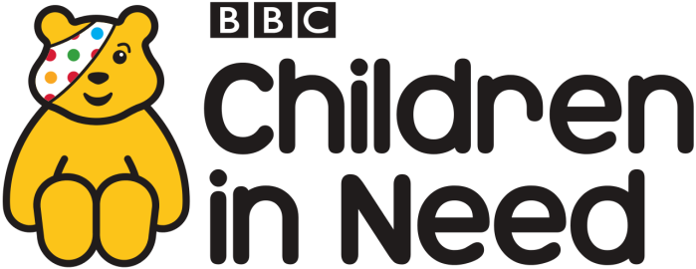

Children in Need Raffle
Friday 15th November 2024

We are holding a raffle in school on Friday to support this year’s Children in Need Appeal.

Tickets cost £1
Tickets can be bought via ParentPay up to 23.59 on Thursday 14th November.
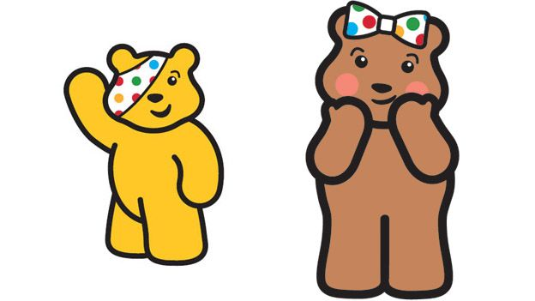
We have two Pudsey Bear first prizes and a selection of additional prizes,
including, Pudsey ears and wristbands!

Children in Need Raffle
Friday 15th November 2024

We are holding a raffle in school on Friday to support this year’s Children in Need Appeal.

Tickets cost £1
Tickets can be bought via ParentPay up to 23.59 on Thursday 14th November.

We have two Pudsey Bear first prizes and a selection of additional prizes,
including, Pudsey ears and wristbands!

