Term | Autumn 1 (7 weeks) | Autumn 2 (8 weeks) | Spring 1 (5 weeks) | Spring 2 (5 weeks 4 days) | Summer 1 (5 weeks 4 days) | Summer 2 (7 weeks)
Main Texts | Narrative (stories with familiar settings) –  Katie Morag Delivers the Mail  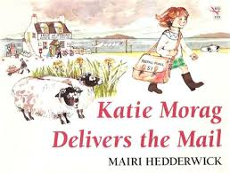  Non-Fiction – Plastic Pollution  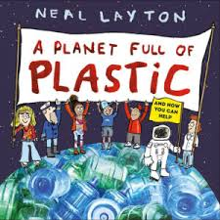 | Narrative (traditional tales with a twist) – Jack and the Baked Beanstalk  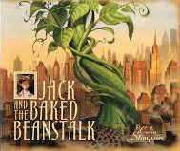  Recount – Letters  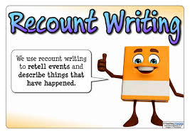  Classic Poetry – The Owl and the Pussycat  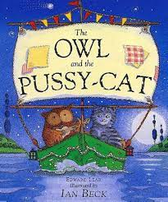 | Narrative (stories by the same author) –  A Right Royal Disaster  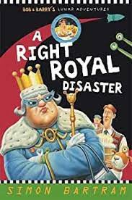  Non-Chronological Report – Space  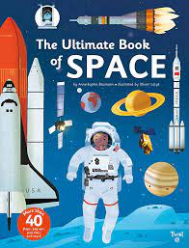 | Narrative (animals adventure stories) –  Wind in the Willows  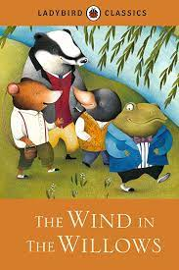  Instructions – Plant a seed  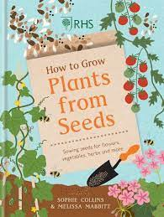  Riddles – Woodland Animals  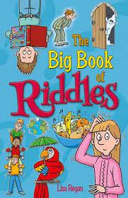 | Narrative (stories as a theme) – The Lighthouse Keeper’s Lunch  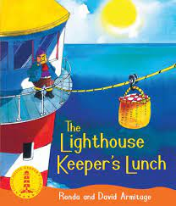  Persuasion – Holiday Advert  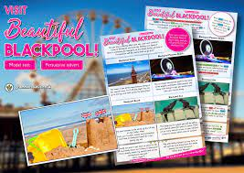  Poems on a Theme – Seasides  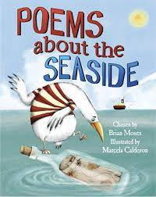 | Last Push Pack (more writing opportunities) – Aladdin  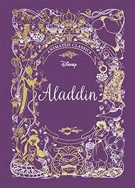  Explanations – What Happens at the Seaside?  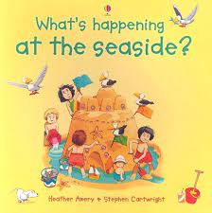
Link Texts | - Katie Morag story collection  - Non-fiction texts all about ‘plastic pollution’  - Plastic-Past, Present and Future by Eun-Ju Kim | - The True Story of the Three Little Pigs by Jon Scieszka  - The Pea and the Princess by Mini Grey  - The Gingerbread Cowboy by Janet Squires  - Interstellar Cinderella by Deborah Underwood  - More examples of recounts (trips, football matches etc)  - The Ugly Duckling by Hans Christian Anderson | - Man on the Moon by Simon Bartram  - The Disappearing Moon by Simon Bartram  - More information texts about Space  - Space encyclopaedias | - Wind in the Willows film clips (Youtube)  - Wind in the Willows longer version  - More instructions on how to… (a range of other products)  - More Riddle books/websites | - The Lighthouse Keeper’s story collection by Ronda and David Armitage  - More real life holiday adverts for Blackpool  - More poetry books about the seaside | - Other versions of ‘Aladdin’ by Disney  - Film versions of ‘Aladdin’ – old and new  - More books about what happens at the seaside
Audience and Purpose | Narrative  Purpose – To write an innovated story changing characters and plot  Audience – share stories with Class Reception | Narrative  Purpose – To write an innovated story changing characters, setting and plot  Audience – Author of the original story | Narrative  Purpose – To write an innovated story changing characters, setting and plot  Audience – share stories with Class 3 | Narrative  Purpose – To write an innovated story changing characters, setting and plot  Audience – story competition (made up) | Narrative  Purpose – To write an innovated story changing characters, setting and plot  Audience – share stories with Class 5/6 | Narrative  Purpose – To write independent pieces linked to text (moderation purposes)  Audience – teachers across school
Audience and Purpose | Non-Chronological Report  Purpose – To inform people about the dangers of plastic pollution  Audience – David Attenborough/BBC | Recounts  Purpose – To inform/discuss the head teacher of any issues/changes needed at school  Audience – Mrs Garner | Non-Chronological Report  Purpose – To inform and recall information about ‘space’  Audience – NASA Space Centre | Instructions  Purpose – To instruct someone on how to plant a successful seed to grow into a plant/flower  Audience – Tatton Park Flower Show | Persuasion  Purpose – To persuade someone to visit Blackpool on holiday  Audience – local shops/bars/restaurants | Explanations  Purpose – To let people know what things happen at the seaside if they were to visit  Audience – holiday makers/travel agents
Audience and Purpose |  | Poetry  Purpose – To write a new poem changing the animals and plot  Audience – Poetry Awards |  | Riddles  Purpose – To create riddles for someone to solve  Audience – share riddles with Class 4 | Poetry  Purpose – To entertain people with poetry about the seaside  Audience – Poetry competition (made up)

