Term | Autumn 1 (7 weeks) | Autumn 2 (8 weeks) | Spring 1 (5 weeks) | Spring 2 (5 weeks 4 days) | Summer 1 and 2
Main Texts | Narrative with a theme  Darwin’s Dragons plus small unit about Pirates  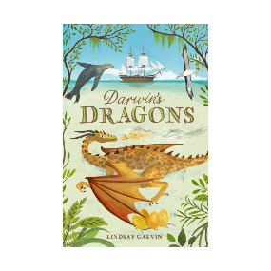  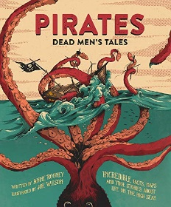  Biographies – Women’s Suffrage  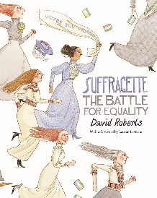 | Short Stories- Francis. (Creating suspense)  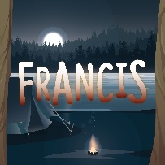  Persuasion – Travel Writing  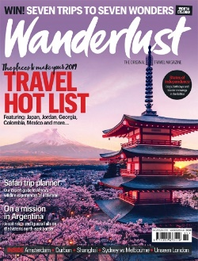  Poetry – Lyrics and Songs | Narrative (Historical Fiction) Letter’s From the Lighthouse  –  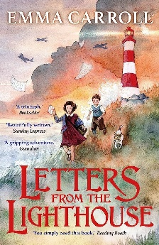  Information Text Hybrid- All About Sikhism  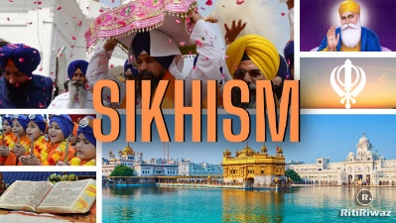 | Older Literature (William Shakespeare)  Macbeth  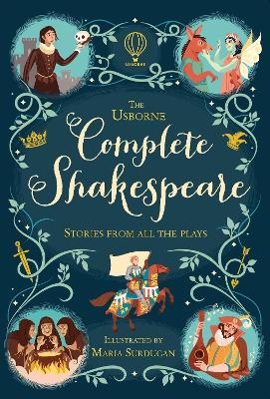  Explanations – The Circulatory System  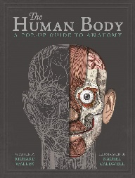  Poems with Imagery – The Lost Words  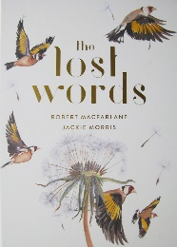 | Narrative with a theme- The 1,000 Year Old Boy (Last Push Pack)  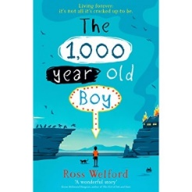  Discussions- Balanced Argument  Classical Poetry– Maya Angelou’s ‘The Caged Bird.’  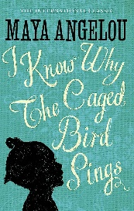
Link Texts | - Survivors by David Long  - Running Wild by Michael Morpurgo  - Kensuke’s Kingdom by Michael Morpurgo |  | - Goodnight Mr Tom by Michelle Monaghan  - Skylark’s War by Hilary Mckay  - Carrie’s War by Nina Bawden | - Romeo and Juliet by William Shakespeare | - Wonder by J L Palacio
Audience and Purpose | Narrative  Purpose – To write an innovated story changing characters and plot  Audience – Send new versions to author Lindsay Galvin | Narrative  Purpose – To write an innovated story changing characters, setting and plot  Audience – Publish final versions for class library | Narrative  Purpose – To write an innovated story changing characters, setting and plot  Audience – Share stories with Class 4 | Narrative  Purpose – To rewrite story of Macbeth  Audience – Share with Parents | Narrative  Purpose – To write an innovated story changing characters, setting and plot  Audience – Share stories with Class 5
Audience and Purpose | Biography  Purpose – To recount the life of a significant individual  Audience – Publish on class website | Persuasion  Purpose – To persuade others to visit a special place  Audience – Published version for class magazine | Information Hybrid  Purpose – To inform others about the religion of Sikhism  Audience – Class 2 and Share with parents/carers | Explanations  Purpose – To explain how the Circulatory System works  Audience – Publish online | Short Stories  Purpose – To write a suspenseful short story based on a short film clip  Audience – Create a spooky ghost story journal | Discussions  Purpose – To develop a balanced argument  Audience – TV show with panel and guests
Audience and Purpose |  | Poetry  Purpose – To write a new song based on song lyrics  Audience – Musical afternoon |  | Riddles  Purpose – To create a nature inspired poem  Audience – Class journal of poems for display | Poetry  Purpose – To write a new innovated poem  Audience – Share at Leavers’ assembly.

