

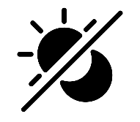




Creation: the act of God creating the world and everyone in it and everything that has been created by God
World: the planet and everything and everyone in it
Belief: trust or confidence in something
Thank: to express gratefulness for something
Harvest: to gather in crops and a Christian celebration
God: the all loving and all powerful being that Christians believe created the world and everything in it
Believe: to accept that something is true
Bible: the holy book for Christians, comprising the Old Testament and the New Testament
Genesis: the first book of Moses for Jewish people and the first book of the Old Testament for Christians
Praise: to show and express gratitude and thanks to God
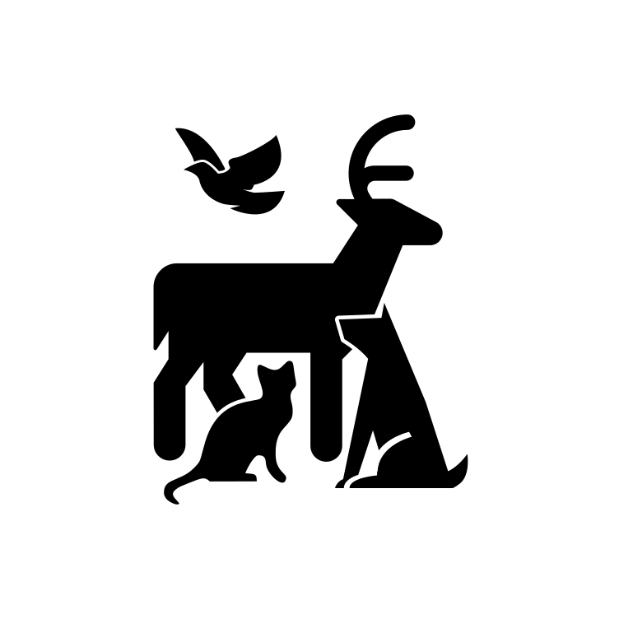
God’s Creation
The first book of the Bible is the book of Genesis which in Chapters 1 and 2 tells Christians the story of how God created the world and everyone in it. This is known as the Story of Creation.
The story tells Christians how God made the world in six days and then on the seventh day he rested. Although some Christians may disagree with the events of Creation, they all believe that God is responsible for creating everything in some way.
Christians have a very strongly held belief that they should look after everything that God has created, and they should thank him for the world and everything in it.
Although Christians can thank God, pray to him and worship him at any time, the festival of Harvest is a key time in the Christian year when they praise him for Creation. This is a time when Christians can thank God for all he has made and for all they have been given. Christians will be singing songs about God as creator and about all he has given people.

Important information
So how does it all work?
Wonderful words
Year One – Knowledge Organiser
Who do Christians say made the world?
Year One
Knowledge
Organiser
UNIT
7

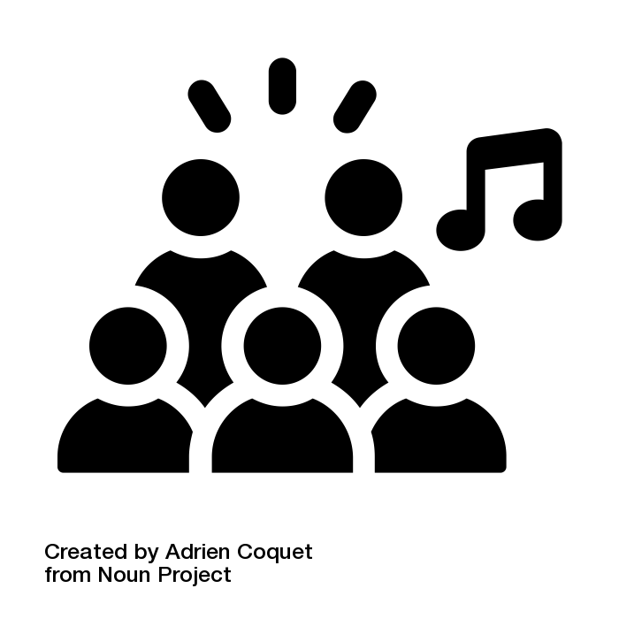
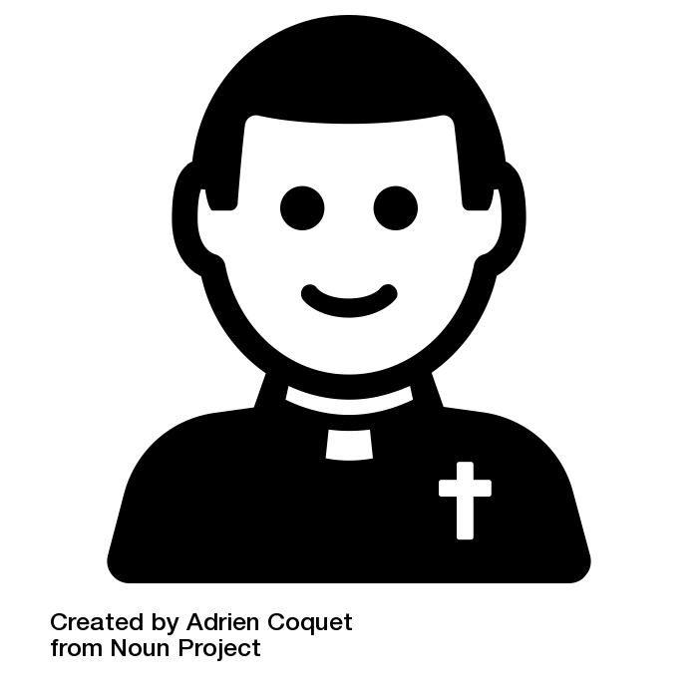
Christians say thank you to God
All icons are used free of charge from Noun Project.
Individual artist credit is given on the following slide.

